IMPEDANCEGUI SOP Version 1.0

Run the latest version of the GUI. This tutorial is for the 3-14-18 version. Also, make a local copy to your personal folder because if you are using the file in my folder then other people will not be able to access it while you are using it.

Overview: The GUI supports individual day files as well as merged day files. There is another tutorial that covers generating day files and merging the day files into a single file. This tutorial will cover how to use the ImpedanceGUI.

**Step 1: Load your data.**

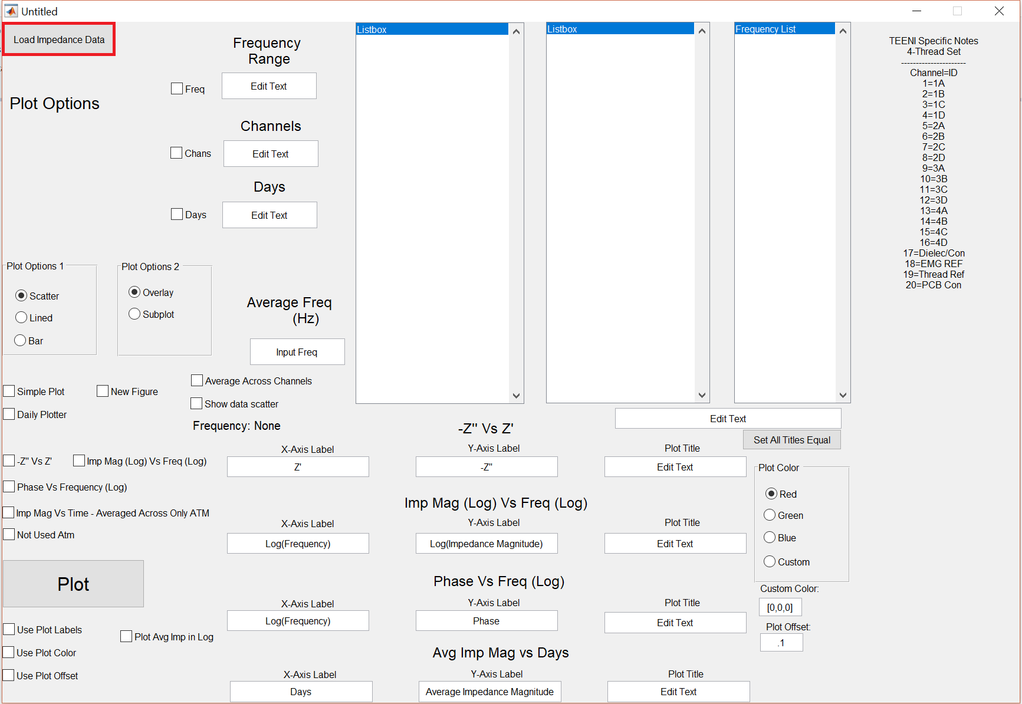

Figure 1: Load Data

Click the “Load Impedance Data” button at the top left of the GUI (Figure 1). This button will open a file selection screen (Figure 2) where you must navigate through the file structure and select your impedance Matlab files (previously generated).

NOTE: You can only select 1 file at a time. If you want to view multiple recording days, you must select a merged data file.

Once a file is loaded, a few things will change (highlighted in red in Figure 3). The GUI will auto-detect the number of days, channels, and recording frequencies from the file structure and report it in the appropriate fields. This information will be used later on to auto-generate figures or create custom figures manually.

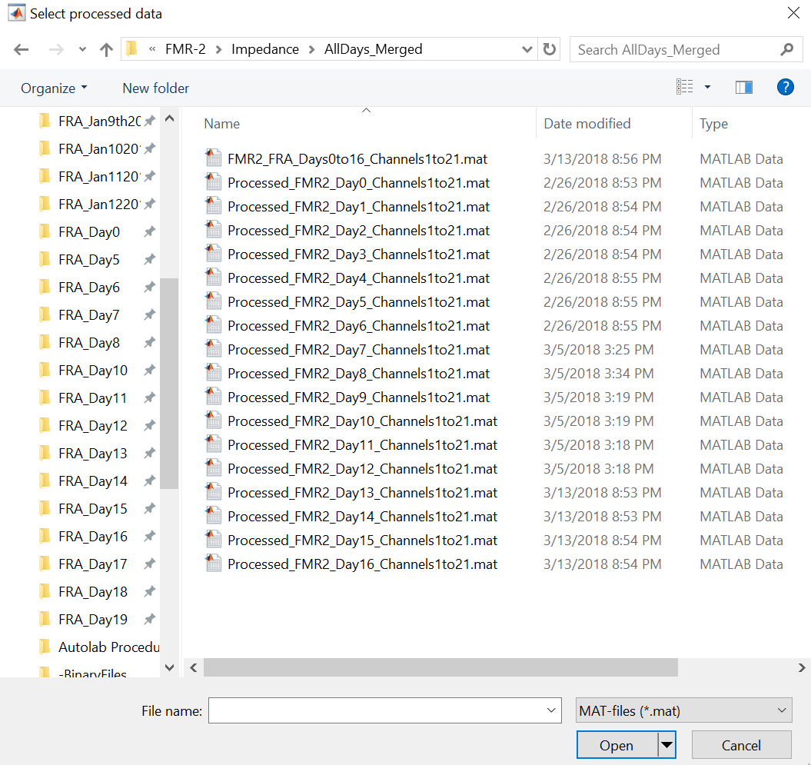

Figure 2: File Selection Screen

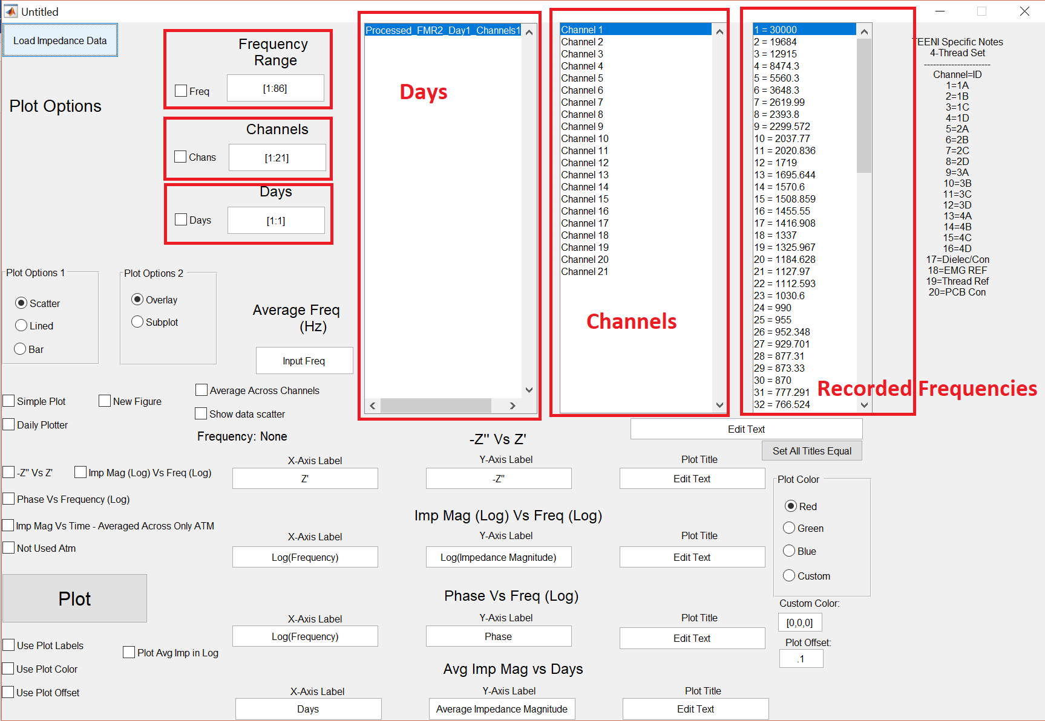

Figure 3: Data Loaded

Once the data is loaded in, there are a three plotting “modes” that can be enabled. “Daily Plotter”, “Simple Plot”, and “Average Across Channels”.  
**Daily Plotter:**Daily plotter is an easy way to view the Nyquist plot of all channels on a given day quickly. If you are interested in a specific frequency, you can input the value into the Average Freq (Hz) box and the software will either select the value you input or the closest value in your dataset. The actual frequency used for the plot will be listed in the “Closest Freq: ####” text. Make sure that the daily plotter option is checked. Review Figure 4 to see the areas mentioned above. Also review Figure 5 for an example of a daily plot. You can specify the frequency range and channels to examine using the top-left boxes.

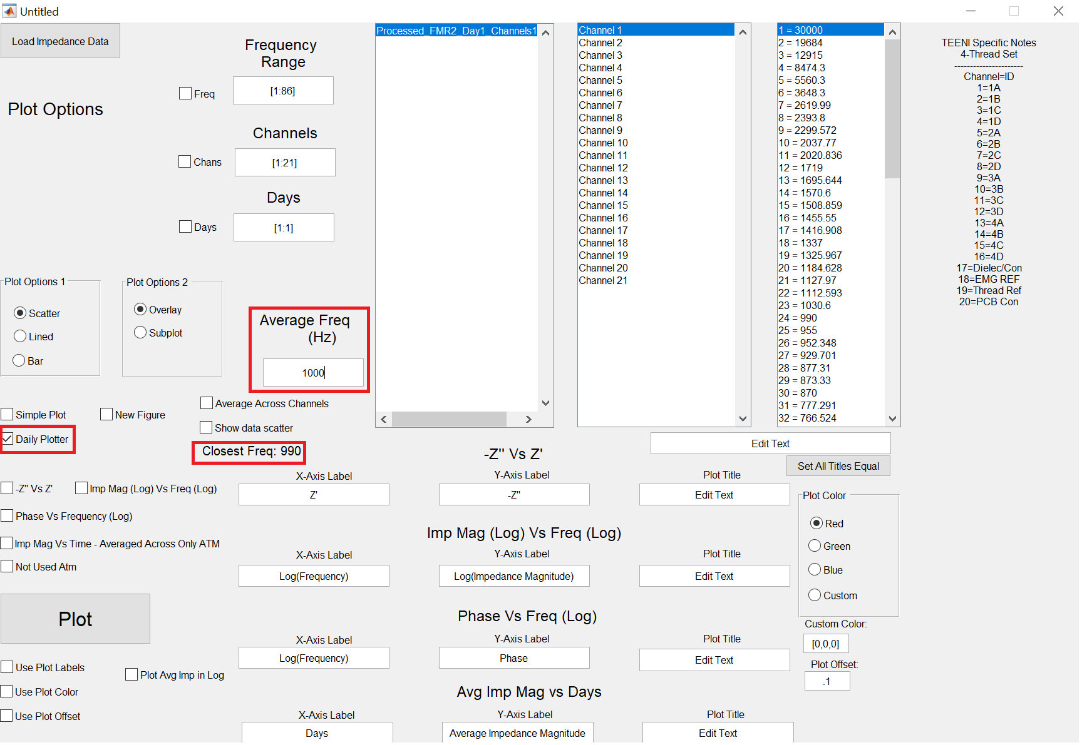

Figure 4: Daily Plotter

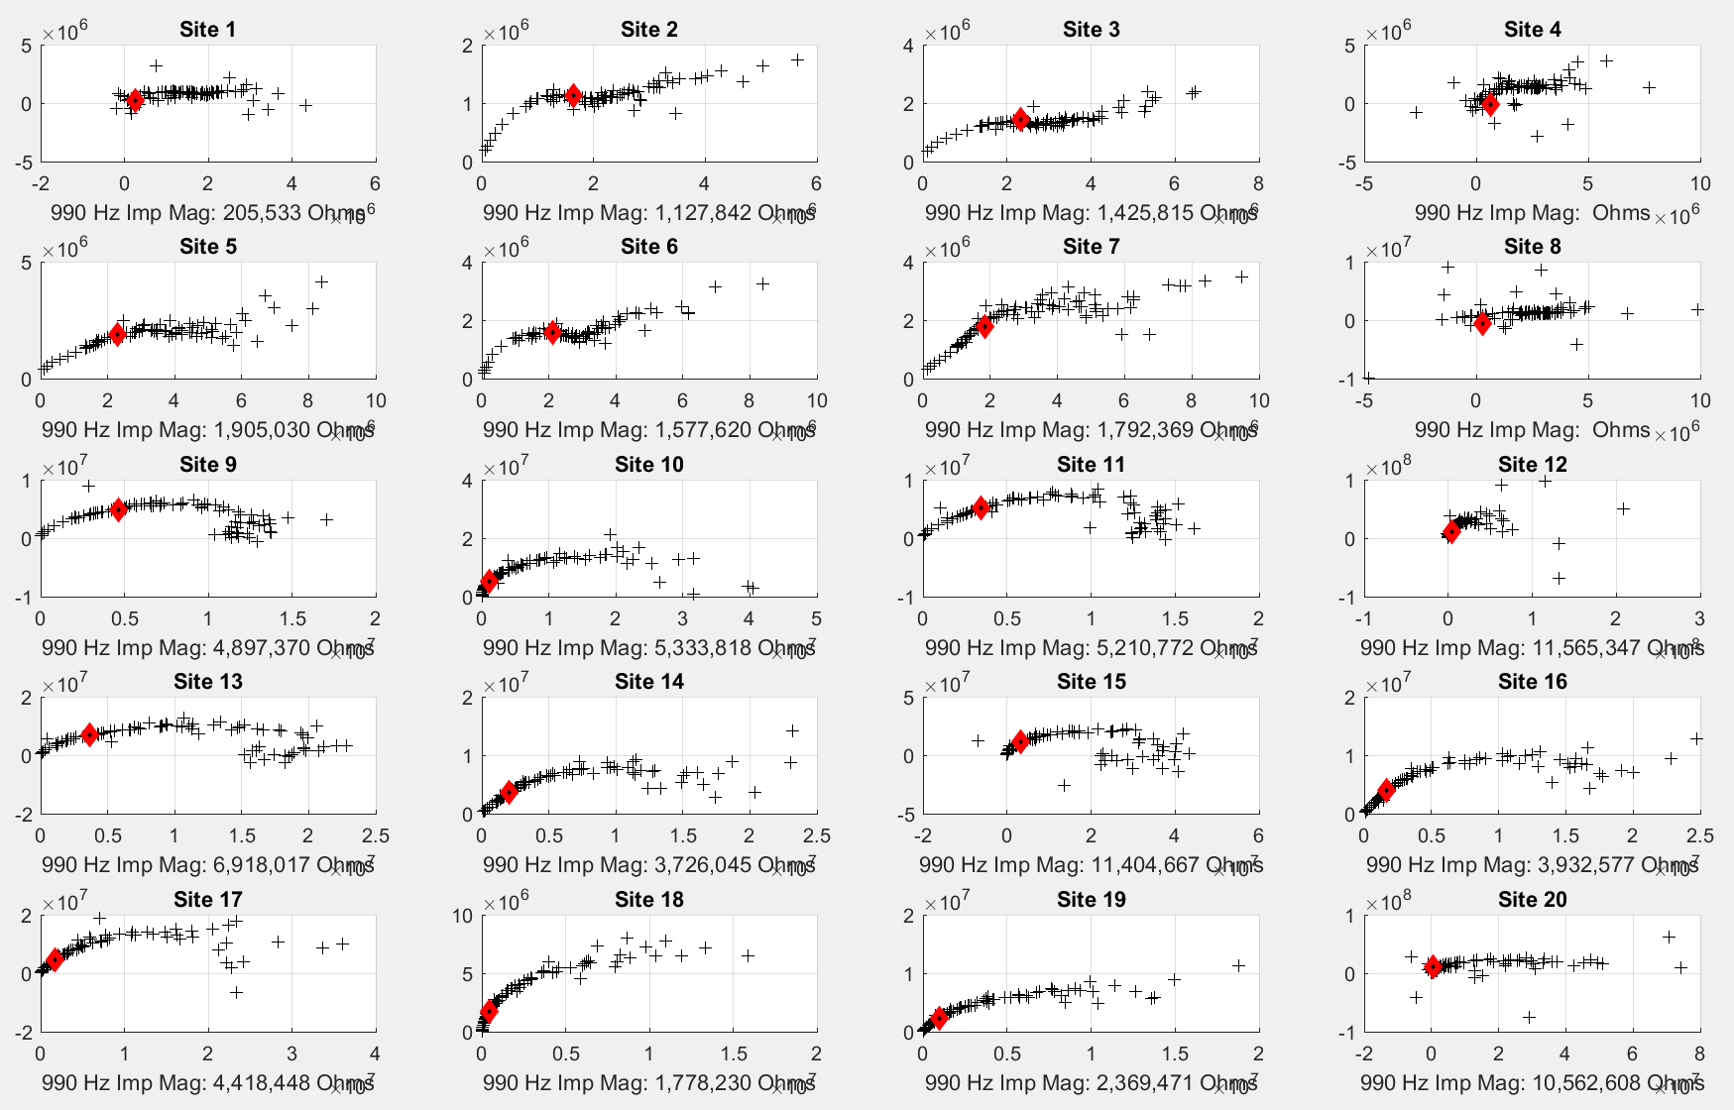  
Figure 5: Daily Plot Example.

The other plot mode is called “Simple Plot” which should probably be renamed in the future since this plot mode has grown to be a little complex.

**Simple Plot:**

An important feature of the simple plot option is the “New Figure” box. Whenever you want to generate a new figure, this box must be checked. If the “New Figure” box is not checked, the GUI will either fail to generate a plot (no previous figures) or add data onto the previously generated figure.

NOTE: Remember to un-check the “New Figure” box after your figures are initially generated or the program will continue to create new figures each time you plot.  
The “Simple Plot” mode is focused on a few plot types: “-Z vs Z”, Imp Mag (Log) Vs Freq (Log), and Phase Vs Freq (Log). The software can keep track of these three types of plots, so if you overlay new plot data then the GUI will update the appropriate plots (see Figure 6 and Figure 7).

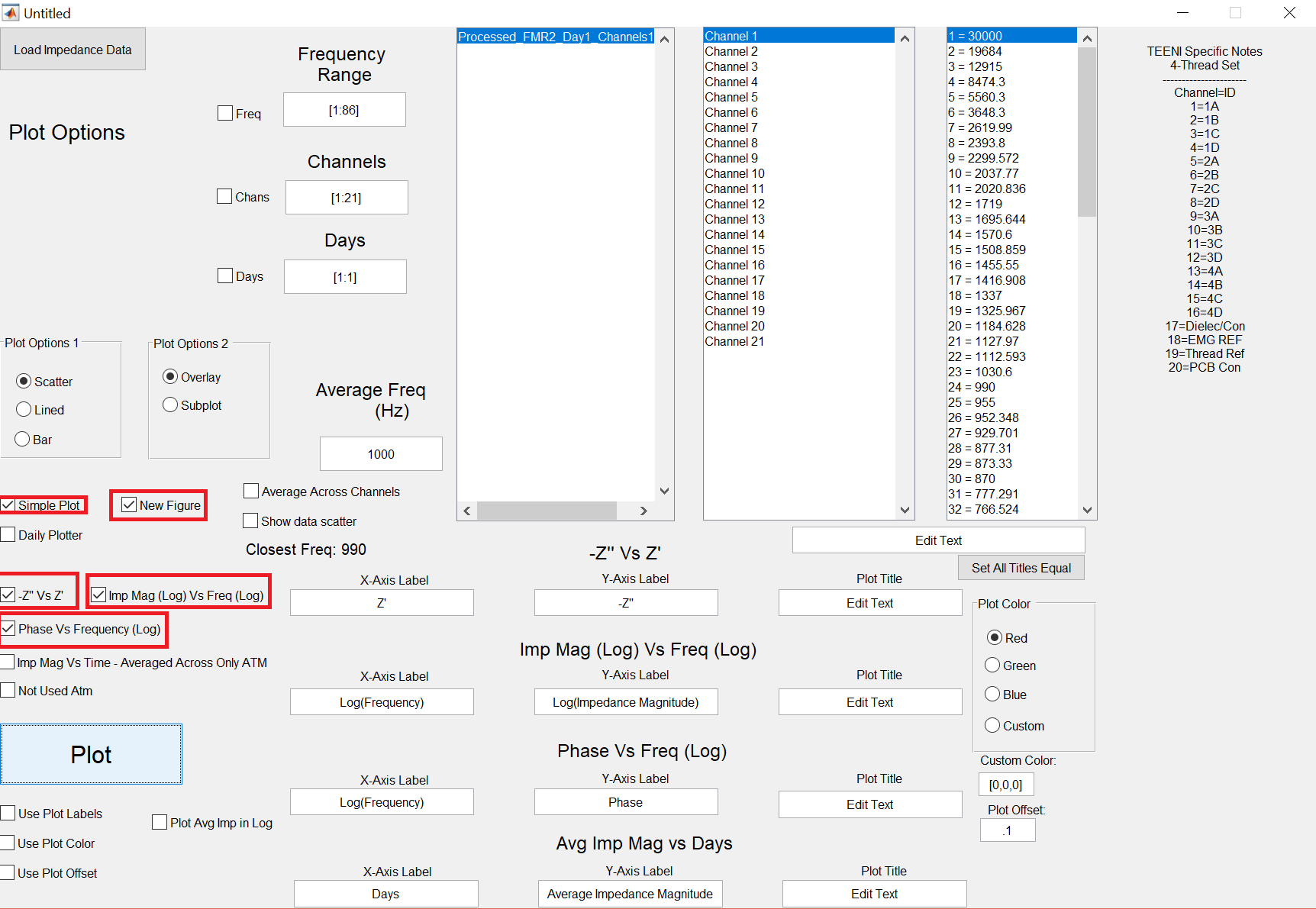  
Figure 6: Simple Plot using all 3 plots.

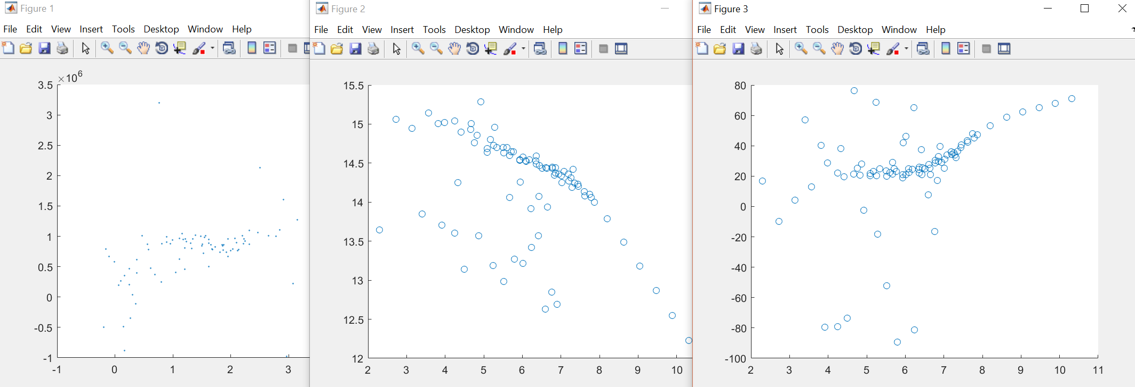

Figure 7: Example of plots generated from Figure 6

If you are not just going quickly to inspect channels and want to add a little more to the generated plots, you can check the “Use Plot Labels” option which will add the appropriate axis and plot titles which can be customized by the user. If all of your plots will have the same overall title, you can enter the text in the yellow box labeled in Figure 8 and click the “Set All Titles Equal” button to automatically change all of the plot titles.

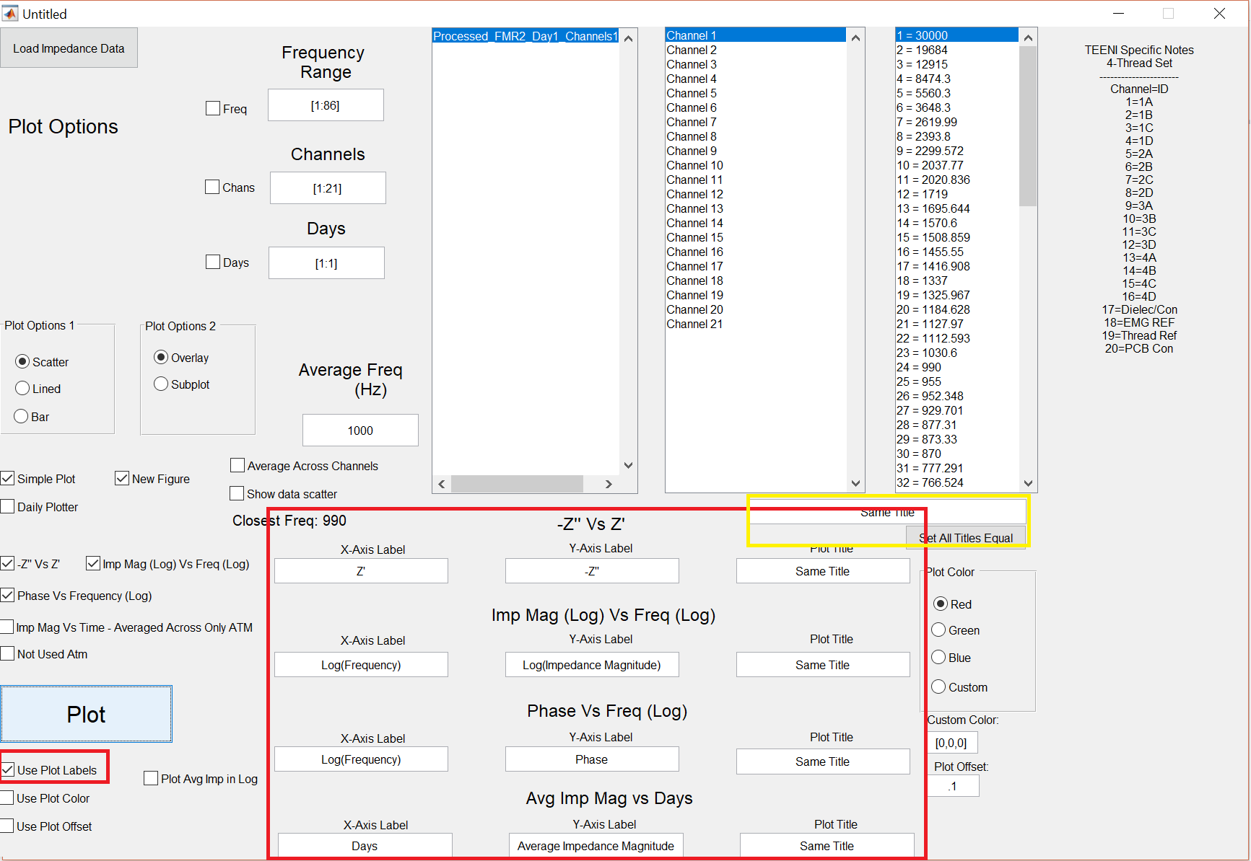

Figure 8: Use Plot Labels

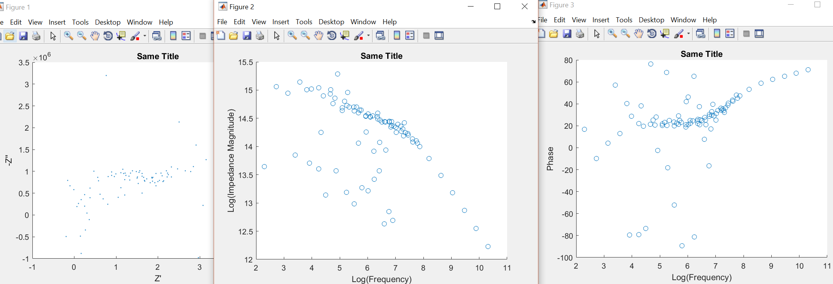  
Figure 9: Example of plots generated from figure 8

Using the tools mentioned above, it is possible to generate plots that examine the same channel over multiple days, multiple channels on a single day, or some other combination you would like to examine. You will just need to be careful about the plot colors, which data is selected when you click “plot”, and the “New Figure” checkbox (see Figure 10).

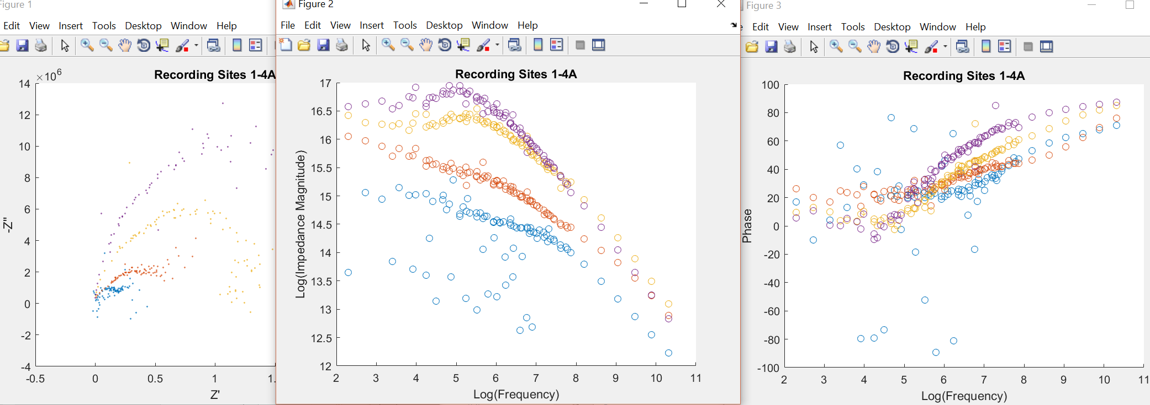  
Figure 10: Custom simple plot.

When using “Simple Plot” with the three default graphs, it is unnecessary to control the plot color manually. The program will automatically plot different colors. Currently, there is no way to add a Legend using the plot colors but this feature is planned for future versions.

It is sometimes desirable to filter out a frequency range (due to low frequency noise) from your simple plots. It is possible to accomplish this by selecting the frequency limit box (see Figure 11). Make sure to double check which frequencies you are removing by examining the “Recorded Frequencies” box (see Figure 3)

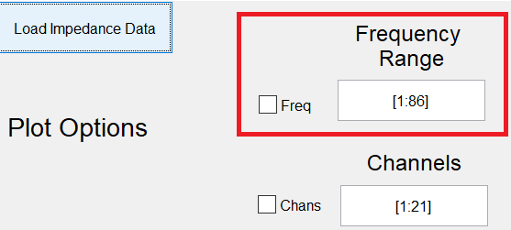Figure 11: Frequency Limiter.

**Average Across Channels:**The Impedance GUI has the ability to average channels over multiple days (see Figure 12). This feature is mainly intended for merged data files that have either multiple trials or multiple recording days depending on the data file structure (covered in another tutorial).

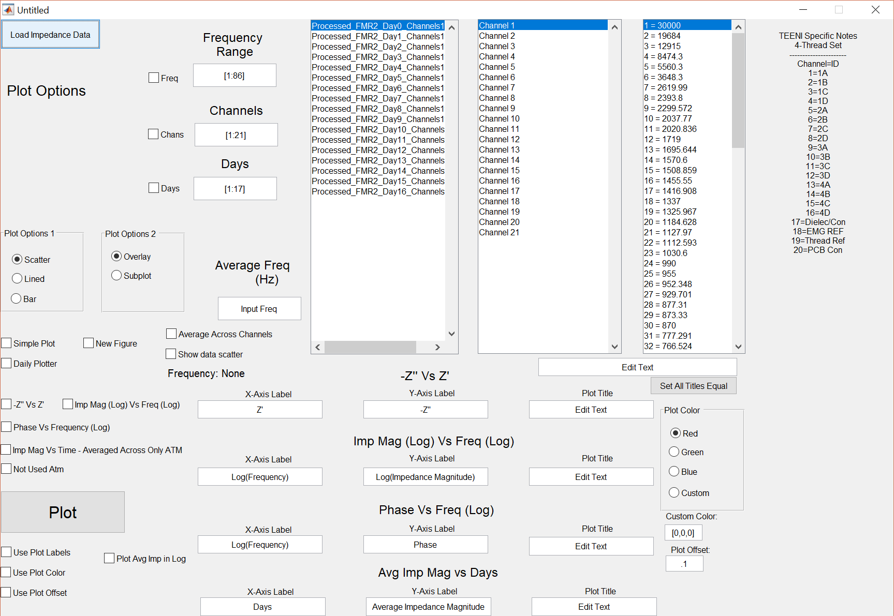  
Figure 12: Multi-day / Multi-trial data

Once a multi-day file has been loaded, you will check the “Average Across Channel” option (see Figure 13).

NOTE: See Figure 13 for the locations discussed below.

After enabling this plot mode, the user needs to select a frequency to use for the analysis. This can be input into the “Average Freq (Hz)” box. If the exact frequency is not available, the software will select the next closest frequency. Whichever frequency was selected will be displayed in the “Closest Freq: ###” text area. The program will then examine the channels the user has selected and average the impedance magnitude across the days the user has selected.

NOTE: Make sure the “Imp Mag Vs Time - Averaged Across Only ATM” is checked before clicking the “Plot” button.

You can also use custom plot labels and plot colors for the lines. Similar to the “Simple Plot” option, you will need to be careful with the “New Figure” check box since a new figure will be created if it is checked and the data will not be overdrawn onto the previous figure. If you want to see the actual data points that were used to calculate the average and standard deviation for each day, make sure that “show data scatter” is checked.

NOTE: I would recommend inspecting each day using the daily plotter to make sure that the frequency you specified does not fall too far from the expected trend-line (see Figure 14). In the future, there may be an interpolation method to estimate a trendline value better, but currently the raw data is used to generate the graphs.

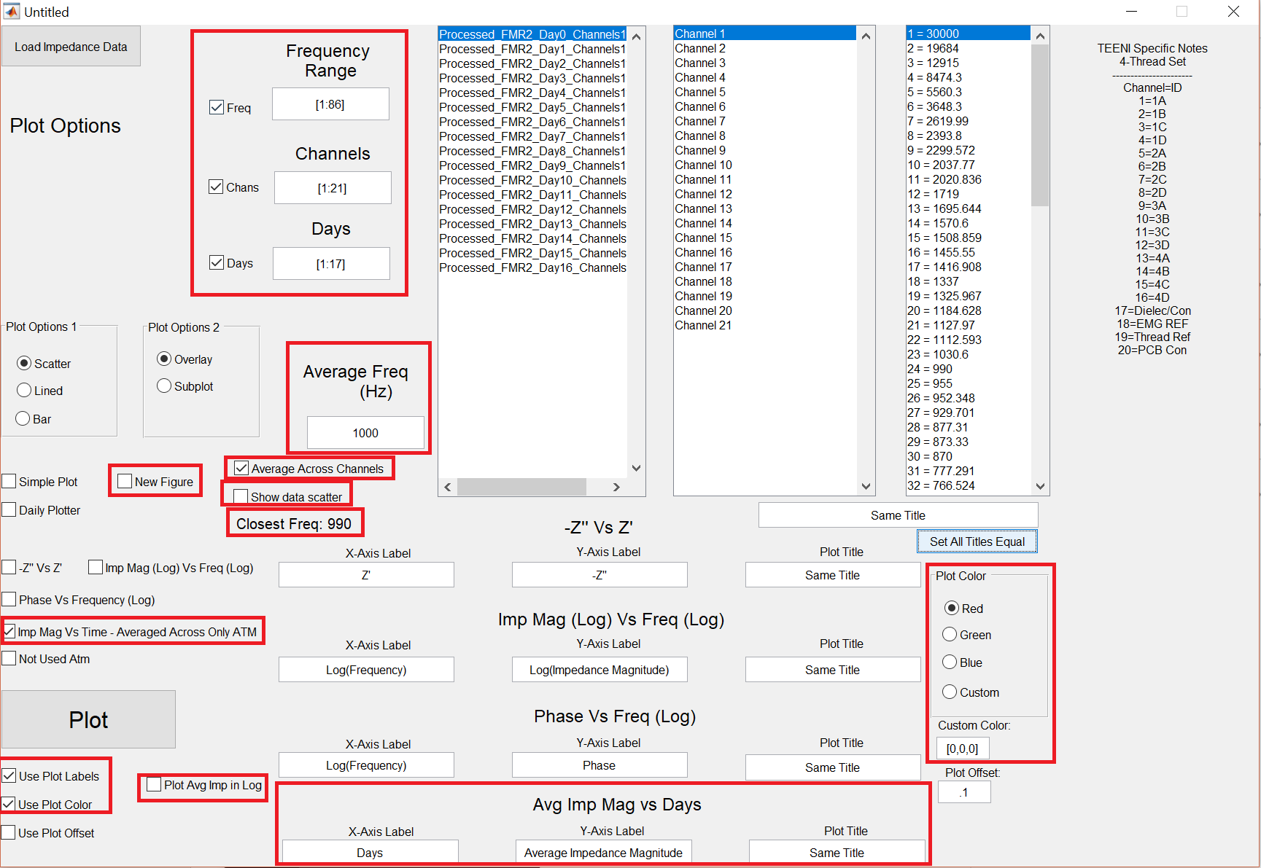  
Figure 13: Options for Average Across Channels plot.

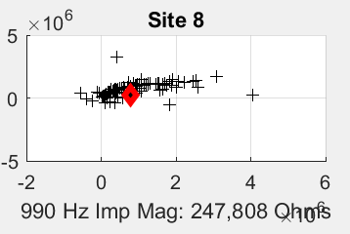  
Figure 14: Frequency off the trend-line.